# **Health & Wellness Supplements Sales Analysis 💊📊**

The global health and wellness supplement market has experienced significant growth over the past several years. To capitalize on this trend, understanding sales performance, customer behavior, and product-level dynamics is critical. This analysis examines **weekly sales data from January 2020 to April 2025** for supplements across three major e-commerce platforms: Amazon, Walmart, and iHerb, spanning the USA, UK, and Canada. The dataset includes key product categories such as Protein, Vitamins, Omega, and Amino Acids, providing a comprehensive view of market trends and operational performance. The primary objective of this study is to identify actionable insights that can drive **revenue optimization, inventory management, and strategic promotions**.

A central focus of the analysis is the relationship between **pricing, discounts, and units sold**. Using Python and Pandas, the dataset was first **cleaned and transformed**, handling missing values, standardizing categorical fields, and calculating derived metrics such as Net Units Sold and Net Revenue:

**df['Net Units Sold'] = df['Units Sold'] - df['Units Returned']**

**df['Net Revenue'] = df['Net Units Sold'] * df['Price']**

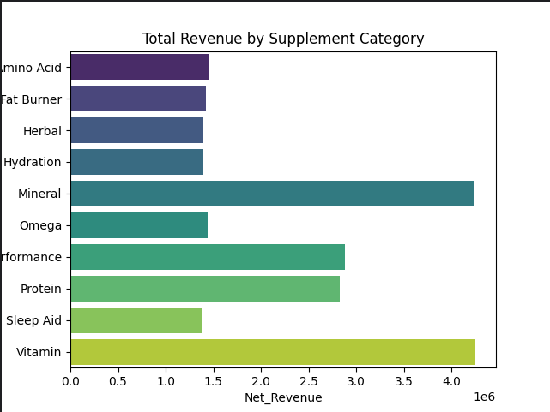

Next, **visual analysis with Seaborn and Matplotlib** revealed that discounts ranging from 10% to 25% effectively stimulate demand across multiple categories, particularly for Protein and Vitamins. Scatterplots were used to demonstrate the correlation between Discount and Net Units Sold:

**sns.scatterplot(data=df, x='Discount', y='Net Units Sold', hue='Category')**

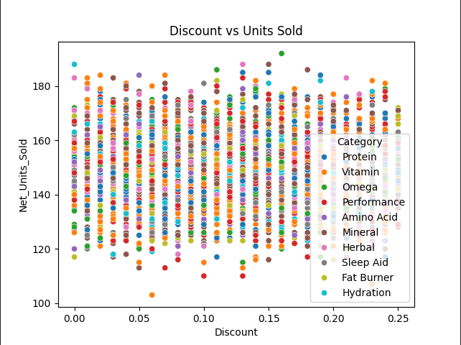

These visualizations highlighted that beyond a 25% discount, additional price reductions yielded diminishing returns in revenue, guiding the recommendation to optimize promotional strategies.

Another key finding concerns **product category performance across platforms**. Aggregating data by Category and Platform using Pandas provided insights into which categories performed best on which platforms:

**platform_summary = df.groupby(['Platform','Category'])['Net Revenue'].sum().reset_index()**

Bar charts generated with Seaborn illustrated that Protein supplements consistently generated the highest revenue on Amazon, while Vitamins performed strongly on iHerb. Returns analysis further showed that Omega products had the highest return rates, particularly in Canada:

**df['Return Rate'] = df['Units Returned'] / df['Units Sold'] * 100**

**returns_summary = df.groupby('Category')['Return Rate'].mean().sort_values()**

**sns.barplot(x=returns_summary.values, y=returns_summary.index, color='crimson')**

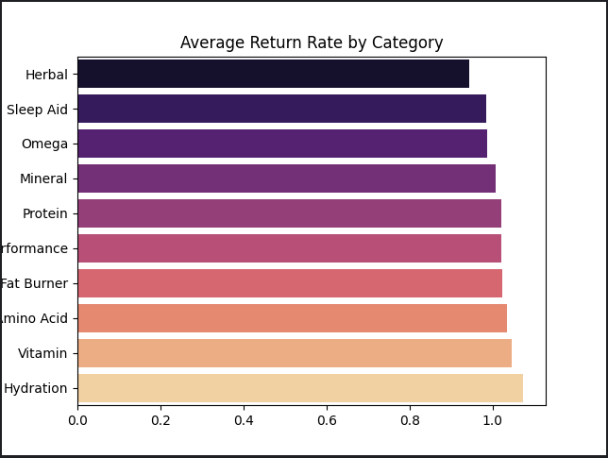

Seasonal trends were examined by extracting monthly periods from the Date column and aggregating net revenue over time:

**df['Month'] = df['Date'].dt.to_period('M')**

**monthly_sales = df.groupby('Month')['Net Revenue'].sum().reset_index()**

**sns.lineplot(data=monthly_sales, x='Month', y='Net Revenue')**

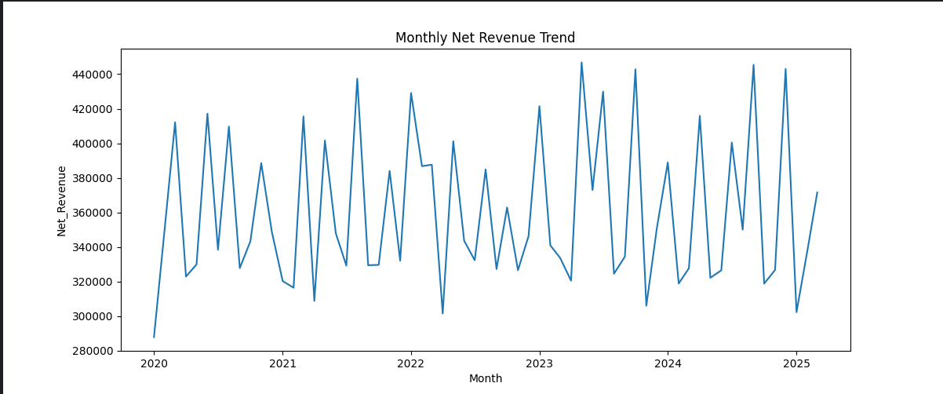

This analysis revealed consistent peaks in January and July, allowing for better **inventory and marketing planning**.

Finally, the impact of returns on net revenue was carefully analyzed, with visualizations highlighting categories and regions where returns were disproportionately affecting revenue. This provided actionable insights for **product quality improvements** and **fulfillment strategies**.

In conclusion, the combination of **data cleaning, feature engineering, aggregation, and visual analysis using Python and Seaborn/Matplotlib** allowed for a comprehensive assessment of supplement sales performance. The findings offer actionable recommendations including optimized discounting strategies, platform-specific inventory allocation, seasonal marketing, and return mitigation, demonstrating how data-driven insights can directly inform strategic business decisions.